**PROJECT REPORT**

**1. INTRODUCTION**

**1.1 Project Overview**

The Project “TrafficTelligence: Advanced Traffic Volume Estimation with Machine Learning” where TrafficTelligence is an advanced system that uses machine learning algorithms to estimate and predict traffic volume with precision. By analyzing historical traffic data, weather patterns, events, and other relevant factors, TrafficTelligence provides accurate forecasts and insights to enhance traffic management, urban planning, and commuter experiences.

**1.2 Purpose**

* **Provide Accurate Traffic Predictions:**  
  Deliver real-time, data-driven traffic volume estimates for urban areas to enhance decision-making.
* **Overcome Traditional Limitations:**  
  Address the shortcomings of manual, delayed, and often unreliable traffic monitoring systems with automated, machine learning-based predictions.
* **Reduce Traffic Congestion:**  
  Enable smarter traffic management to minimize congestion and improve urban mobility for all users.
* **Benefit Multiple Stakeholders:**  
  Serve commuters, city planners, and logistics companies with actionable insights for route optimization, infrastructure planning, and efficient deliveries.
* **Enable Scalable Urban Mobility Solutions:**  
  Support seamless integration across multiple cities or regions and allow easy expansion as new data sources become available.
* **Enhance Travel Efficiency and Satisfaction:**  
  Help individuals and organizations save time, reduce costs, and experience more predictable, stress-free journeys.
* **Support Data-Driven Urban Planning:**  
  Equip city authorities with critical insights needed for evidence-based planning and policy-making.
* **Facilitate Continuous Improvement:**  
  Create a feedback loop where real-world usage and data help refine and optimize the traffic estimation system over time.

**2. IDEATION PHASE**

**2.1 Problem Statement**

**Customer Problem Statement Template:**

Create a problem statement to understand your customer's point of view. The Customer Problem Statement template helps you focus on what matters to create experiences people will love.

A well-articulated customer problem statement allows you and your team to find the ideal solution for the challenges your customers face. Throughout the process, you’ll also be able to empathize with your customers, which helps you better understand how they perceive your product or service.

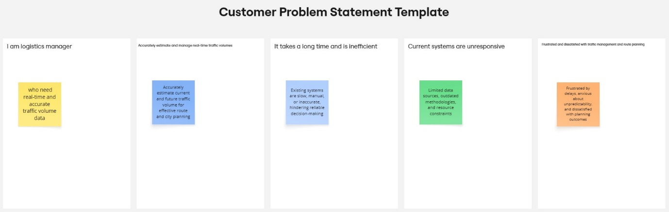

Reference: <https://miro.com/templates/customer-problem-statement/>

|  |  |  |  |  |  |
| --- | --- | --- | --- | --- | --- |
| **Problem Statement (PS)** | **I am (Customer)** | **I’m trying to** | **But** | **Because** | **Which makes me feel** |
| PS-1 | A city planner or commuter | Accurately predict and manage current and future traffic volumes | The data I receive is often outdated or incomplete | Current systems rely on slow, manual reporting methods | Frustrated, powerless, stressed |
| PS-2 | A logistics manager or daily traveller | Plan optimal delivery routes or daily commutes | Traffic volumes are unpredictable and rarely automated | Traffic systems don’t integrate real-time, diverse datasets | Anxious, dissatisfied, uncertain |

**2.2 Empathy Map Canvas**

**Empathy Map Canvas:**

An empathy map is a simple, easy-to-digest visual that captures knowledge about a user’s behaviours and attitudes.

It is a useful tool to helps teams better understand their users.

Creating an effective solution requires understanding the true problem and the person who is experiencing it. The exercise of creating the map helps participants consider things from the user’s perspective along with his or her goals and challenges.

**Example:**

Reference: <https://www.mural.co/templates/empathy-map-canvas>

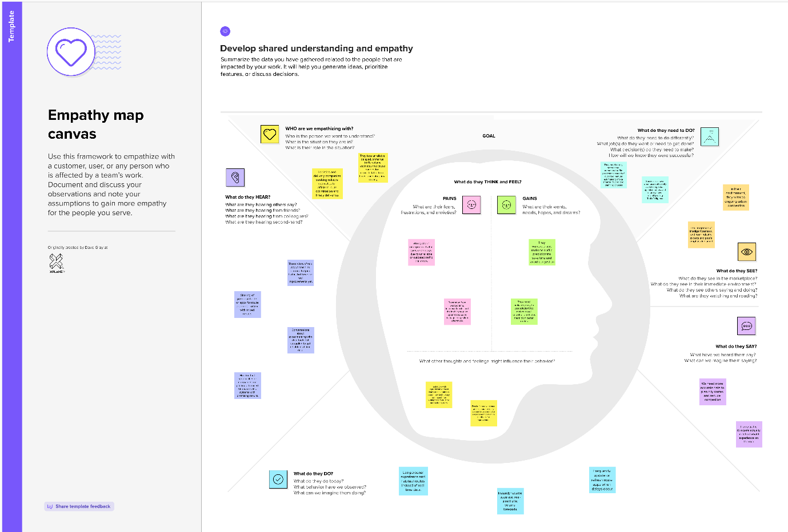

**2.3 Brainstorming**

**Brainstorm & Idea Prioritization Template:**

Brainstorming provides a free and open environment that encourages everyone within a team to participate in the creative thinking process that leads to problem solving. Prioritizing volume over value, out-of-the-box ideas are welcome and built upon, and all participants are encouraged to collaborate, helping each other develop a rich amount of creative solutions.

Use this template in your own brainstorming sessions so your team can unleash their imagination and start shaping concepts even if you're not sitting in the same room.

Reference: <https://www.mural.co/templates/brainstorm-and-idea-prioritization>

**Step-1: Team Gathering, Collaboration and Select the Problem Statement**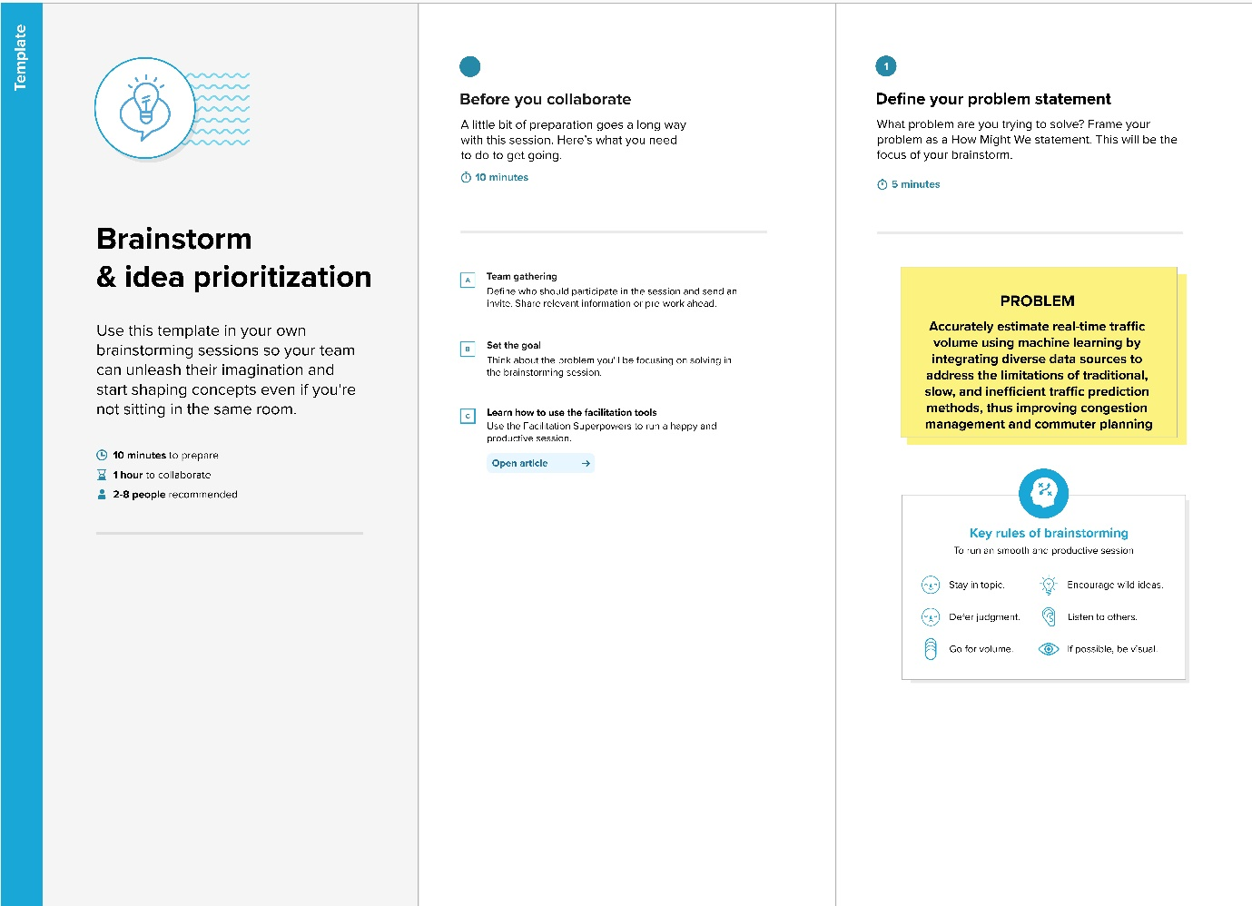

**Step-2: Brainstorm, Idea Listing and Grouping**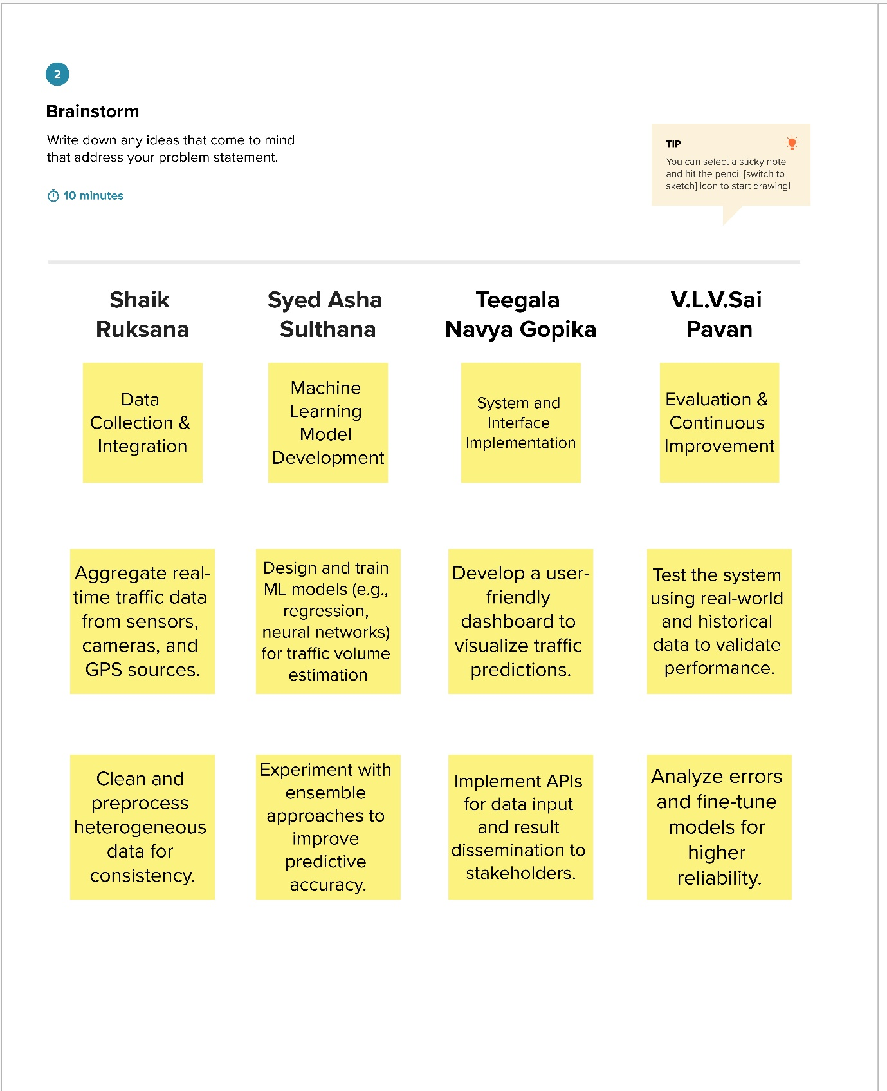

**Step-3: Idea Prioritization**

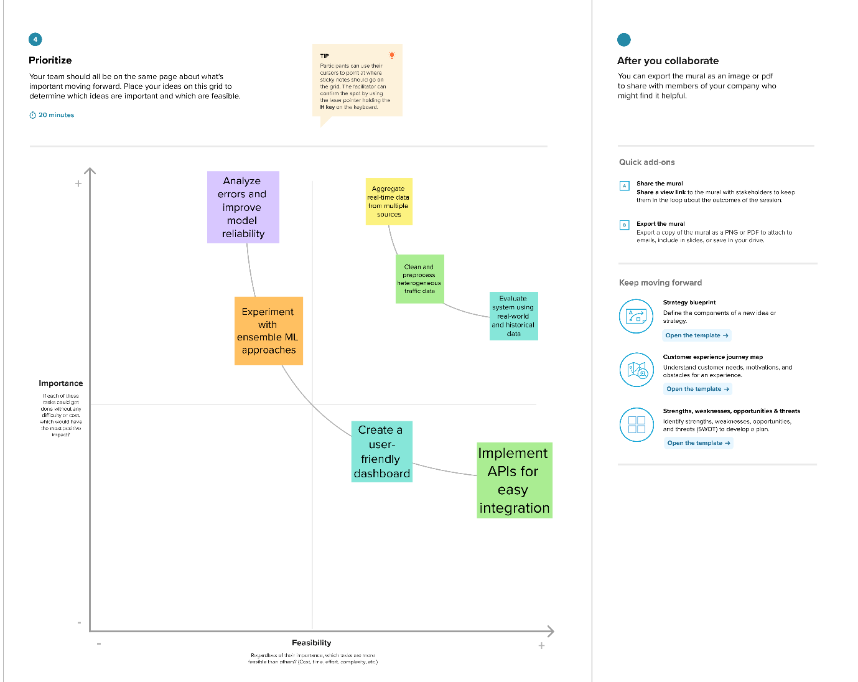

**3. REQUIREMENT ANALYSIS**

**3.1 Solution Requirement**

**Functional Requirements:**

Following are the functional requirements of the proposed solution.

|  |  |  |
| --- | --- | --- |
| **FR No.** | **Functional Requirement (Epic)** | **Sub Requirement (Story / Sub-Task)** |
| FR-1 | Real-Time Data Collection | - Integrate with city sensors, traffic cameras, and GPS data sources. - Automate data ingestion and storage. - Support for multiple data formats (CSV, JSON, API streams). |
| FR-2 | Machine Learning-Based Traffic Volume Estimation | - Develop and train predictive models for traffic volume. - Support continuous model retraining with new data. - Provide real-time prediction API endpoints for authorized users. |
| FR-3 | Visualization and Reporting | - Design interactive dashboards for traffic volume visualization. - Implement historical and predictive reporting features. - Allow data export in standard formats (CSV, PDF |
| FR-4 | User and System Integration | - Implement secure user authentication and role-based access. - Provide APIs for integration with external government and logistics platforms. - Enable notifications/alerts for significant traffic events. |

**Non-functional Requirements:**

Following are the non-functional requirements of the proposed solution.

|  |  |  |
| --- | --- | --- |
| **FR No.** | **Non-Functional Requirement** | **Description** |
| NFR-1 | **Usability** | The system must have an intuitive, easy-to-navigate interface for all user roles. |
| NFR-2 | **Security** | Data must be protected via encryption in transit and at rest; adhere to local data privacy standards |
| NFR-3 | **Reliability** | System should maintain >99% uptime (excluding planned maintenance) and offer error recovery. |
| NFR-4 | **Performance** | Predictions and data retrieval must occur within ≤2 seconds for real-time user experience. |
| NFR-5 | **Availability** | The service must be accessible 24/7, with support for redundant infrastructure to minimize downtime. |
| NFR-6 | **Scalability** | Capable of handling increased data volumes and concurrent users as deployment expands to new regions or cities. |

**3.2 Data Flow Diagram**

**Data Flow Diagrams:**

A Data Flow Diagram (DFD) is a traditional visual representation of the information flows within a system. A neat and clear DFD can depict the right amount of the system requirement graphically. It shows how data enters and leaves the system, what changes the information, and where data is stored.

**User Stories**

Use the below template to list all the user stories for the product.

| **User Type** | **Functional Requirement (Epic)** | **User Story Number** | **User Story / Task** | **Acceptance criteria** | **Priority** | **Release** |
| --- | --- | --- | --- | --- | --- | --- |
| Commuter | Real-time traffic information display | USN-1 | As a commuter, I want to view up-to-date traffic volumes on my route so I can choose the fastest path. | User sees present traffic data mapped and receives timely updates | High | Sprint-1 |
| City Planner | Traffic analysis dashboard | USN-2 | As a planner, I want to access a dashboard with historical and predicted traffic data for different zones. | Planners download/analyze reports showing accurate past/future trends. | High | Sprint-1 |
| Logistics Manager | Route optimization through API | USN-3 | As a logistics manager, I want to plug our software into an API to get real-time traffic estimates for routing. | API is accessible, responds in <1s, and returns accurate traffic predictions. | Low | Sprint-2 |
| Data Scientist | Data quality monitoring | USN-4 | As a data scientist, I want to monitor incoming data streams for quality and missing data alerts. | System flags gaps/anomalies, with alerts sent within 5 min of issues. | Medium | Sprint-1 |
| Platform Admin | System health and uptime monitoring | USN-5 | As an admin, I want automated system health checks and uptime alerts to ensure the service is reliable. | Uptime is monitored; downtime alerts sent within 1 min of failure. | High | Sprint-1 |

**3.3 Technology Stack**

**Technical Architecture:**

The Deliverable shall include the architectural diagram as below and the information as per the table1 & table 2

**Example: Order processing during pandemics for offline mode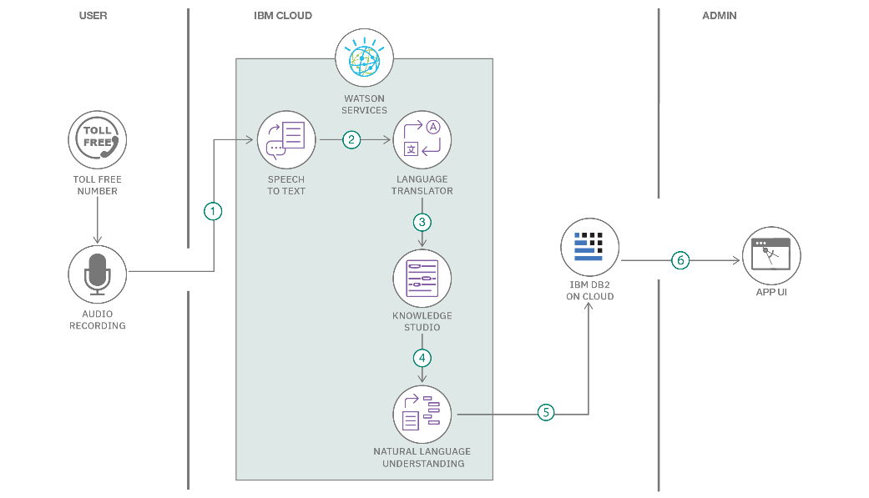eference:** [**https://developer.ibm.com/patterns/ai-powered-backend-system-for-order-processing-during-pandemics/**](https://developer.ibm.com/patterns/ai-powered-backend-system-for-order-processing-during-pandemics/)

Guidelines:

Include all the processes (As an application logic / Technology Block)

Provide infrastructural demarcation (Local / Cloud)

Indicate external interfaces (third party API’s etc.)

Indicate Data Storage components / services

Indicate interface to machine learning models (if applicable)

**Table-1 : Components & Technologies:**

|  |  |  |  |
| --- | --- | --- | --- |
| **S.No** | **Component** | **Description** | **Technology** |
|  | User Interface | How user interacts with application e.g.  Web UI, Mobile App, Chatbot etc. | HTML, CSS, JavaScript / Angular Js / React Js etc. |
|  | Application Logic-1 | Logic for a process in the application | Java / Python |
|  | Application Logic-2 | Logic for a process in the application | IBM Watson STT service |
|  | Application Logic-3 | Logic for a process in the application | IBM Watson Assistant |
|  | Database | Data Type, Configurations etc. | MySQL, NoSQL, etc. |
|  | Cloud Database | Database Service on Cloud | IBM DB2, IBM Cloudant etc. |
|  | File Storage | File storage requirements | IBM Block Storage or Other Storage Service or Local Filesystem |
|  | External API-1 | Purpose of External API used in the application | IBM Weather API, etc. |
|  | External API-2 | Purpose of External API used in the application | Aadhar API, etc. |
|  | Machine Learning Model | Purpose of Machine Learning Model | Object Recognition Model, etc. |
|  | Infrastructure (Server / Cloud) | Application Deployment on Local System / Cloud  Local Server Configuration:  Cloud Server Configuration : | Local, Cloud Foundry, Kubernetes, etc. |

**Table-2: Application Characteristics:**

| **S.No** | **Characteristics** | **Description** | **Technology** |
| --- | --- | --- | --- |
|  | Open-Source Frameworks | List the open-source frameworks used | Technology of Opensource framework |
|  | Security Implementations | List all the security / access controls implemented, use of firewalls etc. | e.g. SHA-256, Encryptions, IAM Controls, OWASP etc. |
|  | Scalable Architecture | Justify the scalability of architecture (3 – tier, Micro-services) | Technology used |
|  | Availability | Justify the availability of application (e.g. use of load balancers, distributed servers etc.) | Technology used |
|  | Performance | Design consideration for the performance of the application (number of requests per sec, use of Cache, use of CDN’s) etc. | Technology used |

**4. PROJECT DESIGN**

**4.1 Problem Solution Fit**

**Problem – Solution Fit Template:**

The Problem-Solution Fit simply means that you have found a problem with your customer and that the solution you have realized for it actually solves the customer’s problem. It helps entrepreneurs, marketers and corporate innovators identify behavioral patterns and recognize what would work and why

**Purpose:**

* Solve complex problems in a way that fits the state of your customers.
* Succeed faster and increase your solution adoption by tapping into existing mediums and channels of behavior.
* Sharpen your communication and marketing strategy with the right triggers and messaging.
* Increase touch-points with your company by finding the right problem-behavior fit and building trust by solving frequent annoyances, or urgent or costly problems.
* **Understand the existing situation in order to improve it for your target group.**

**Template:**

**4.2 Proposed Solution**

**Proposed Solution Template:**

Project team shall fill the following information in the proposed solution template.

|  |  |  |
| --- | --- | --- |
| **S.No.** | **Parameter** | **Description** |
|  | Problem Statement (Problem to be solved) | Accurate real-time estimation of traffic volumes is lacking, causing congestion and inefficiency. |
|  | Idea / Solution description | Develop an ML-powered system that integrates live sensor, camera, and GPS data to predict and visualize real-time traffic volumes. |
|  | Novelty / Uniqueness | Combines multi-source real-time data with innovative ML models for highly accurate, automated predictions. |
|  | Social Impact / Customer Satisfaction | Reduces congestion, saves commuter time, improves urban planning, and enhances reliability for public and commercial users. |
|  | Business Model (Revenue Model) | Subscription-based model for city authorities, premium dashboard services for logistics companies, API licensing for developers. |
|  | Scalability of the Solution | Can be deployed in multiple cities or countries, easily integrates new data sources, and supports growing data volumes. |

**4.3 Solution Architecture**

**Solution Architecture:**

Solution architecture is a complex process – with many sub-processes – that bridges the gap between business problems and technology solutions. Its goals are to:

* Find the best tech solution to solve existing business problems.
* Describe the structure, characteristics, behavior, and other aspects of the software to project stakeholders.
* Define features, development phases, and solution requirements.
* Provide specifications according to which the solution is defined, managed, and delivered.

**Example - Solution Architecture Diagram:**

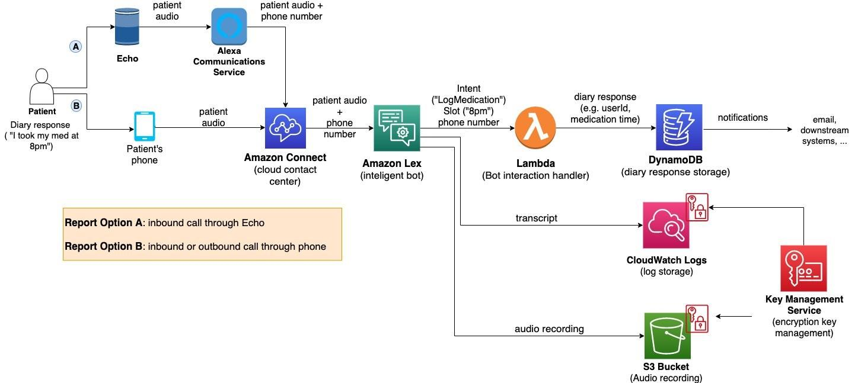

*Figure 1: Architecture and data flow of the voice patient diary sample application*

**5.PROJECT PLANNING & SCHEDULING**

**5.1 Project Planning**

| **Sprint** | **Functional Requirement (Epic)** | **User Story Number** | **User Story / Task** | **Story Points** | **Priority** | **Team Members** |
| --- | --- | --- | --- | --- | --- | --- |
| Sprint-1 | **Pre requisites** | USN-1 | As a user, I can install the **Anaconda navigator software** | 5 | Medium | 1. Vusa Leela Venkata Sai Pavan 2. Shaik Ruksana 3. Syed Asha Sulthana 4. Teegala Navya Gopika |
| Sprint-1 | Data Collection. | USN-2 | As a user, I will Collect the dataset or Create the dataset | 4 | Low | 1. Vusa Leela Venkata Sai Pavan 2. Shaik Ruksana 3. Syed Asha Sulthana 4. Teegala Navya Gopika |
| Sprint-2 | Data Pre-processing. | USN-3 | As a user, I can   * Import the Libraries. * Importing the dataset. * Checking for Null Values. * Data Visualization. * Taking care of Missing Data. * Feature Scaling. * Splitting Data into Train and Test. | 2 | High | 1. Vusa Leela Venkata Sai Pavan 2. Shaik Ruksana 3. Syed Asha Sulthana 4. Teegala Navya Gopika |
| Sprint-2 | Model Building | USN-4 | As a user, I can   * Import the model building Libraries * Initializing the model * Training and testing the model * Evaluation of Model * Save the Model | 4 | Medium | 1. Vusa Leela Venkata Sai Pavan 2. Shaik Ruksana 3. Syed Asha Sulthana 4. Teegala Navya Gopika |
| Sprint-3 | Application Building | USN-5 | As a user, I can   * Create an HTML file * Build a Python Code * Run the App | 3 | High | 1. Vusa Leela Venkata Sai Pavan 2. Shaik Ruksana 3. Syed Asha Sulthana 4. Teegala Navya Gopika |
| Sprint-3 | Output Process | USN-6 | As a user,   * Copy the HTTP link and paste it in google link tab, it will display the form page * Enter the values as per the form and click on predict button * It will redirect to the page based on prediction output * The output will be displayed in the prediction text as Estimated Traffic volume is in units. | 1 | Medium | 1. Vusa Leela Venkata Sai Pavan 2. Shaik Ruksana 3. Syed Asha Sulthana   Teegala Navya Gopika |

**Project Tracker, Velocity & Burndown Chart: (4 Marks)**

| **Sprint** | **Total Story Points** | **Duration** | **Sprint Start Date** | **Sprint End Date (Planned)** | **Story Points Completed (as on Planned End Date)** | **Sprint Release Date (Actual)** |
| --- | --- | --- | --- | --- | --- | --- |
| Sprint-1 | 20 | 6 Days | 16 June 2025 | 21 June 2025 | 20 | 21 June 2025 |
| Sprint-2 | 20 | 6 Days | 18 June 2025 | 23 June 2025 | 20 | 23 June 2025 |
| Sprint-3 | 20 | 6 Days | 20 June 2025 | 25 June 2025 | 20 | 25 June 2025 |
| Sprint-4 | 20 | 6 Days | 22 June 2025 | 27 June 2025 | 20 | 27 June 2025 |

**Velocity:**

Imagine we have a 10-day sprint duration, and the velocity of the team is 20 (points per sprint). Let’s calculate the team’s average velocity (AV) per iteration unit (story points per day)

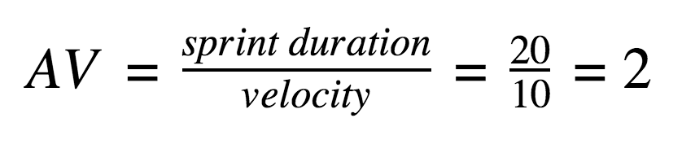

**Burndown Chart:**

A burn down chart is a graphical representation of work left to do versus time. It is often used in agile[software development](https://www.visual-paradigm.com/scrum/what-is-agile-software-development/) methodologies such as [Scrum](https://www.visual-paradigm.com/scrum/scrum-in-3-minutes/). However, burn down charts can be applied to any project containing measurable progress over time.

[**https://www.visual-paradigm.com/scrum/scrum-burndown-chart/**](https://www.visual-paradigm.com/scrum/scrum-burndown-chart/)

[**https://www.atlassian.com/agile/tutorials/burndown-charts**](https://www.atlassian.com/agile/tutorials/burndown-charts)

**Reference:**

[**https://www.atlassian.com/agile/project-management**](https://www.atlassian.com/agile/project-management)

[**https://www.atlassian.com/agile/tutorials/how-to-do-scrum-with-jira-software**](https://www.atlassian.com/agile/tutorials/how-to-do-scrum-with-jira-software)

[**https://www.atlassian.com/agile/tutorials/epics**](https://www.atlassian.com/agile/tutorials/epics)

[**https://www.atlassian.com/agile/tutorials/sprints**](https://www.atlassian.com/agile/tutorials/sprints)

[**https://www.atlassian.com/agile/project-management/estimation**](https://www.atlassian.com/agile/project-management/estimation)

[**https://www.atlassian.com/agile/tutorials/burndown-charts**](https://www.atlassian.com/agile/tutorials/burndown-charts)

**6.FUNCTIONAL AND PERFORMANCE TESTING**

**6.1 Performance Testing**

**Model Performance Testing:**

Project team shall fill the following information in model performance testing template.

|  |  |  |  |
| --- | --- | --- | --- |
| **S.No.** | **Parameter** | **Values** | **Screenshot** |
|  | Metrics | **Regression Model:** MAE - , MSE - , RMSE - , R2 score -  **Classification Model:** Confusion Matrix - , Accuray Score- & Classification Report - |  |
|  | Tune the Model | Hyperparameter Tuning -  Validation Method - |  |

**7. RESULTS**

**7.1 Output Screenshots**

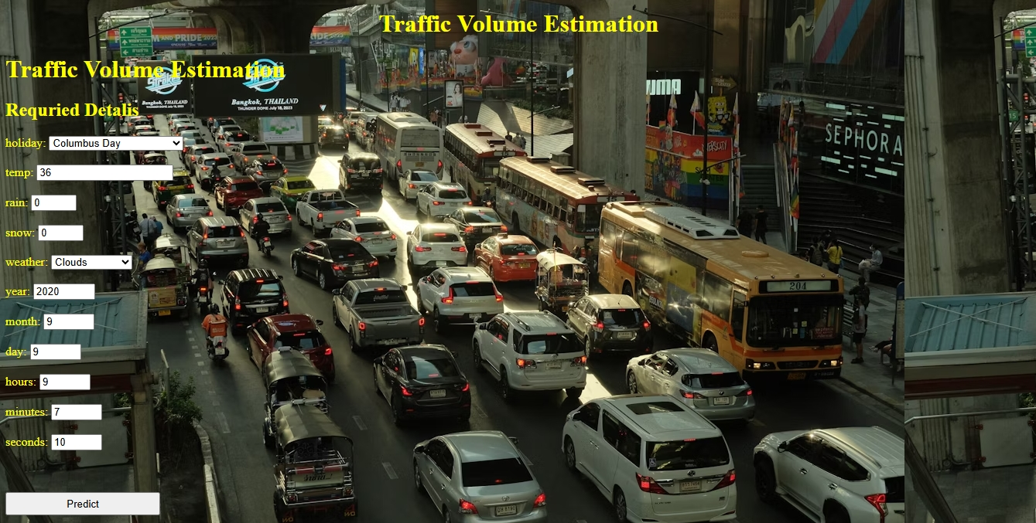

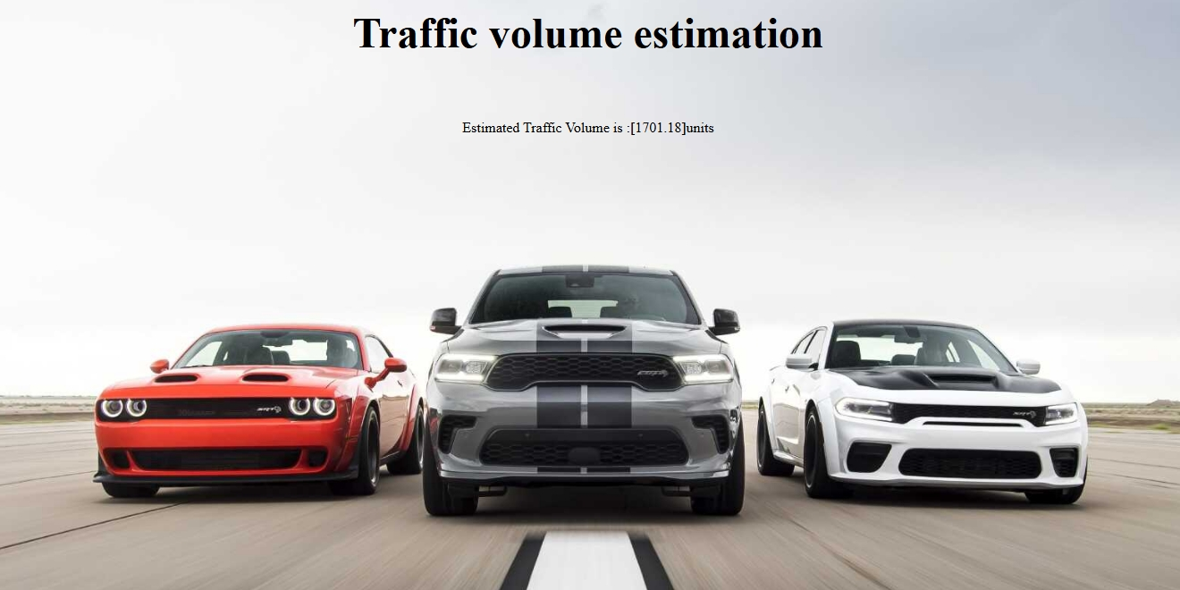

**8.ADVANTAGES & DISADVANTAGES**

**Advantages:**

* **Accurate Real-Time Traffic Predictions**
  + Utilizes machine learning models and multiple data sources (sensors, cameras, GPS) to provide precise, current traffic volume estimates.
* **Automation and Scalability**
  + Reduces manual effort with automated data collection and analysis.
  + Can be deployed across various cities or regions, accommodating expanding datasets.
* **Improved Congestion Management**
  + Helps authorities and commuters proactively manage bottlenecks, reducing traffic jams and travel times.
* **Enhanced Decision-Making for Stakeholders**
  + Benefits commuters, logistics companies, and city planners with actionable insights for route optimization, schedule planning, and infrastructure development.
* **Supports Data-Driven Urban Planning**
  + Supplies city authorities with reliable, granular traffic data to inform infrastructure investments and policy-making.
* **Continuous Learning and Improvement**
  + Machine learning enables the system to improve over time as more data is collected and feedback is integrated.

**Disadvantages:**

* **Data Quality and Availability Issues**
  + Model accuracy depends heavily on the quality and comprehensiveness of input data. Missing or incorrect data can degrade performance.
* **Complexity of Integration**
  + Combining various real-time data sources (sensors, cameras, GPS) can be technically challenging and may require significant setup and maintenance.
* **Potential High Initial Costs**
  + Implementing advanced sensors, data storage, and machine learning infrastructure involves upfront investment.
* **Privacy and Security Concerns**
  + Aggregating and analyzing real-time location and traffic data may raise privacy issues and requires strong data protection measures.
* **Model Limitations in Unusual Cases**
  + Unexpected events (e.g., major accidents, unplanned road closures, extreme weather) can lead to inaccurate predictions if not adequately represented in historical data.
* **Ongoing Maintenance Needs**
  + Regular updates, model retraining, and hardware maintenance are necessary to ensure sustained accuracy and reliability.

**9.CONCLUSION**

TrafficTelligence: Advanced Traffic Volume Estimation with Machine Learning demonstrates a transformative approach to urban traffic management by harnessing the power of machine learning and diverse real-time data sources. The system effectively addresses the shortcomings of traditional traffic monitoring methods—such as delayed, manual, or unreliable estimations—by delivering automated, precise, and scalable traffic volume predictions**.**

**10.FUTURE SCOPE**

1**. Integration of Emerging Data Sources**

* Utilize IoT sensors, connected vehicle data, and mobile device analytics for richer real-time insights.
* Incorporate data from smart city infrastructure and social media for enhanced situational awareness.

**2. Expansion to Multimodal Transportation**

* Extend volume estimation to bikes, public transit, and pedestrian flow for holistic urban mobility management.
* Support route optimization that considers all transportation modes and interconnectivity.

**3. Predictive and Prescriptive Analytics**

* Move beyond estimation to proactively forecast future traffic events, incidents, and demand surges.
* Offer prescriptive recommendations, such as alternate routes or signal timing adjustments to ease congestion.

**4. AI-Driven Adaptive Systems**

* Implement self-learning models that continuously adapt based on new patterns and user feedback.
* Leverage reinforcement learning for dynamic traffic signal control and route planning.

**5. Enhanced User Personalization**

* Develop personalized alerts and recommendations tailored to user preferences and habits.
* Support integration with personal navigation and fleet management platforms.

**6. Geographic and Market Scalability**

* Deploy solutions across multiple cities, regions, or countries with region-specific adaptation.
* Enable service scaling for both dense urban centers and less-connected rural areas.

**7. Collaboration and Policy Support**

* Enable data sharing with government agencies for emergency response, urban planning, and sustainability initiatives.
* Support analytics for regulatory planning, such as emission reduction and smart zoning.

**8. Continuous Improvement through Feedback Loops**

* Incorporate feedback mechanisms to learn from real-world deployment and user interactions.
* Regularly update models to address emerging urban challenges, such as infrastructure changes or evolving mobility trends.

**9. Advanced Visualization and Decision Support**

* Develop interactive dashboards for stakeholders with predictive heatmaps, anomaly detection, and what-if scenario analysis.
* Provide simulation tools for policy makers to test the impact of infrastructure or policy changes.

**10. Research and Innovation**

* Collaborate with academia and industry to advance research in traffic modeling, anomaly detection, and explainable AI.
* Pilot cutting-edge techniques such as federated learning for privacy-preserving model training across cities and organizations.

**11.APPENDIX**

**Source Code:**



**Dataset Link:**



**GitHub & Project Demo Link:**

[**Saipavan39u/TrafficTelligence-Advanced-Traffic-Volume-Estimation-with-Machine-Learning**](https://github.com/Saipavan39u/TrafficTelligence-Advanced-Traffic-Volume-Estimation-with-Machine-Learning)

**Project Demo Link:**

